**PRESS RELEASE**

**COMMUNICATIONS AND MEDIA TEAM OF THE 43RD ASEAN SUMMIT 2023**

**No.13/SP/TKM-ASEAN2023/ENG/8/2023**

**AP II Optimizes Soekarno-Hatta Airport Operations for the 43rd ASEAN Summit 2023**

**Jakarta, 30 August 2023** – State-owned airport operator PT Angkasa Pura II (Persero) has prepared operational plans at Soekarno-Hatta Tangerang Airport, Banten, for welcoming heads of state and delegates of the 43rd ASEAN Summit 2023 in Jakarta.

AP II has upgraded various facilities at Soekarno-Hatta Airport, one of the largest airports in Indonesia that becomes the entry point for delegates of the ASEAN Summit.

"We have upgraded the existing facilities at Soekarno-Hatta Airport, especially in the VIP building as heads of state will enter through this VIP building. We are also providing a line at International Terminal 3 as non-VIP state delegates will pass through Terminal 3 and the commercial area lounge. The preparation is around 70-80 percent to complete," said Soekarno Hatta International Airport’s Senior Manager of Branch Communication & Legal, Holik Muardi, in Tangerang, Wednesday, 30 August.

He said that to ensure the optimization of airport operations, his office has also coordinated with all existing stakeholders to ensure the smooth arrival, transit, and departure of the delegation.

"We are coordinating with Immigration and Customs so they can prepare a fast track for delegates. We will also provide a help desk in the arrival area of Terminal 3 International to help the event committee pick up delegates,"," he said.

AP II will also optimize security for heads of state arriving at Soekarno-Hatta Airport. Besides the Aviation Security (Avsec), the Indonesian National Armed Force (TNI) and the Indonesian National Police (Polri) will also be involved in the airport security arrangement.

"For security, we will coordinate with the TNI/Polri. We will deploy 6,341 personnel to secure the ASEAN Summit (delegations' arrival) at Soekarno-Hatta Airport," said Holik.

Meanwhile, Kertajati Airport ofMajalengka inWest Java and Yogyakarta International Airport (YIA) will also prepare for 43rd ASEAN Summit 2023.

"The ASEAN Summit delegates are expected to arrive on 4 September 2023. For state aircraft parking, apart from Soekarno-Hatta Airport, Kertajati Airport will also provide around 18 parking stands and YIA Airport Yogyakarta will prepare around 3 parking stands," said Holik. (Azmi Syamsul Ant/TR/PR)

***

For more information, please contact:

**Director General of Public Information and Communications of the Ministry of Communications and Informatics – Usman Kansong (0816785320).**

Get more information at <http://asean2023.id>, <https://infopublik.id/kategori/asean-2023>, and <https://indonesia.go.id/kategori/ragam-asean-2023>

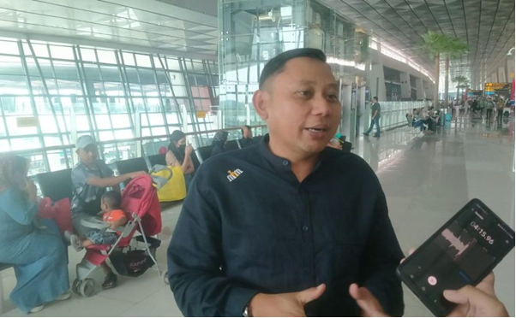

Soekarno Hatta Internasional Airport’s Senior Manager of Branch Communication & Legal, Banten, Holik Muardi. ANTARA/Azmi.